**DevOps Task 6**

Jenkins Groovy Kubernetes



Task-6 :-  
  
Perform third task with the help of Jenkins coding file ( called as jenkinsfile approach ) and perform the with following phases:  
  
1. Create container image that’s has Jenkins installed using dockerfile Or You can use the Jenkins Server on RHEL 8/7  
2. When we launch this image, it should automatically starts Jenkins service in the container.  
3. Create a job chain of job1, job2, job3 and job4 using build pipeline plugin in Jenkins   
4. Job2 ( Seed Job ) : Pull the Github repo automatically when some developers push repo to Github.  
5. Further on jobs should be pipeline using written code using Groovy language by the developer  
6. Job1 :   
1. By looking at the code or program file, Jenkins should automatically start the respective language interpreter installed image container to deploy code on top of Kubernetes ( eg. If code is of PHP, then Jenkins should start the container that has PHP already installed )  
2. Expose your pod so that testing team could perform the testing on the pod  
3. Make the data to remain persistent using PVC ( If server collects some data like logs, other user information )  
7. Job3 : Test your app if it is working or not.  
8. Job4 : if app is not working , then send email to developer with error messages and redeploy the application after code is being edited by the developer

Pre-requisites :-

- yOu will require a docker image that has jenkins and kubectl install then u can perform the same practical

- Minikube to be setup completely so that u can work on it by making it cluster

- Some Other things also u can see them in the document

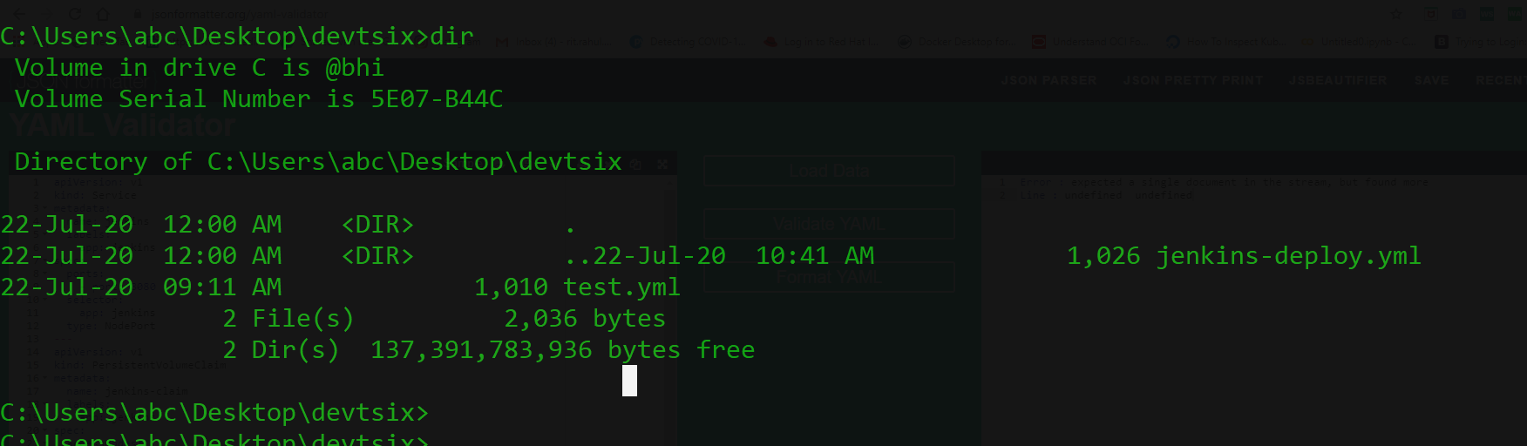

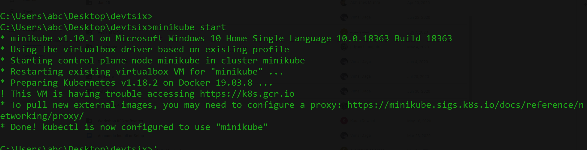

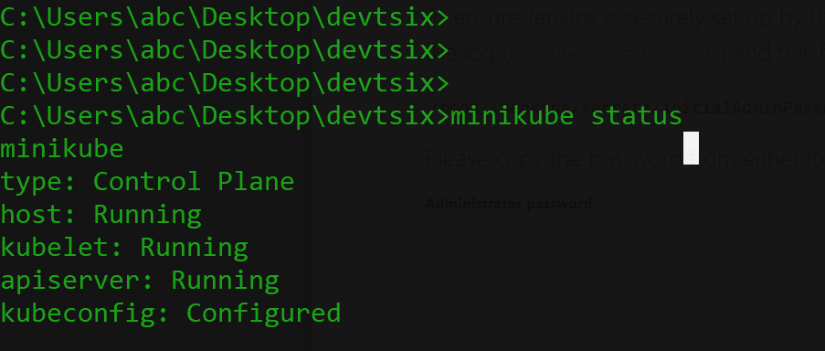

Checking ip of minikube and port for launching jenkins !!

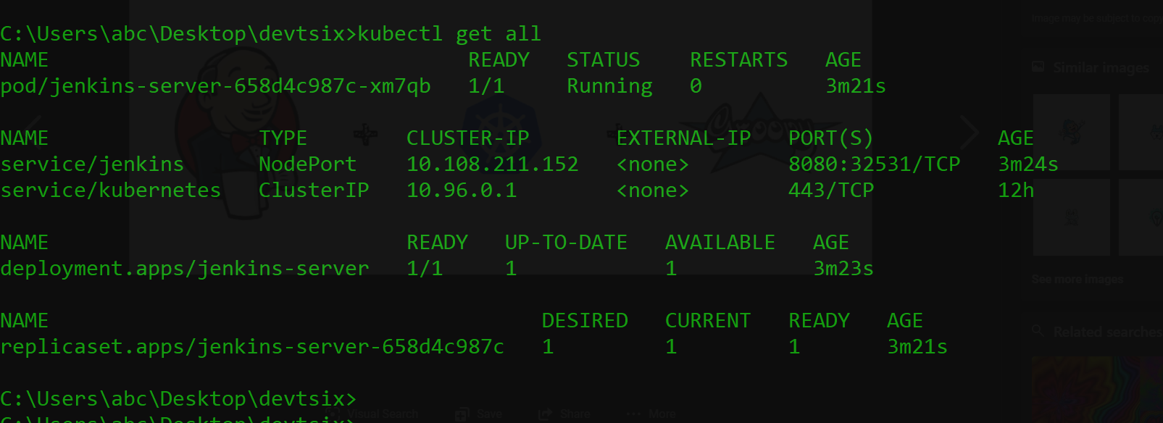

Here we go , now we will setup our jenkins

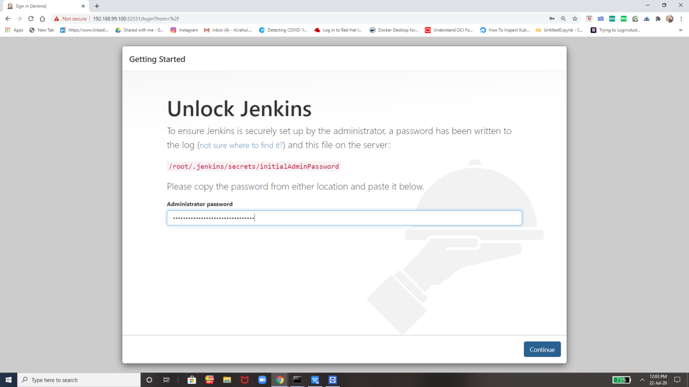

For Password we will check its logs and then will get it

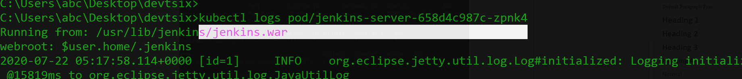

Here inside this file we will get password of jenkins .

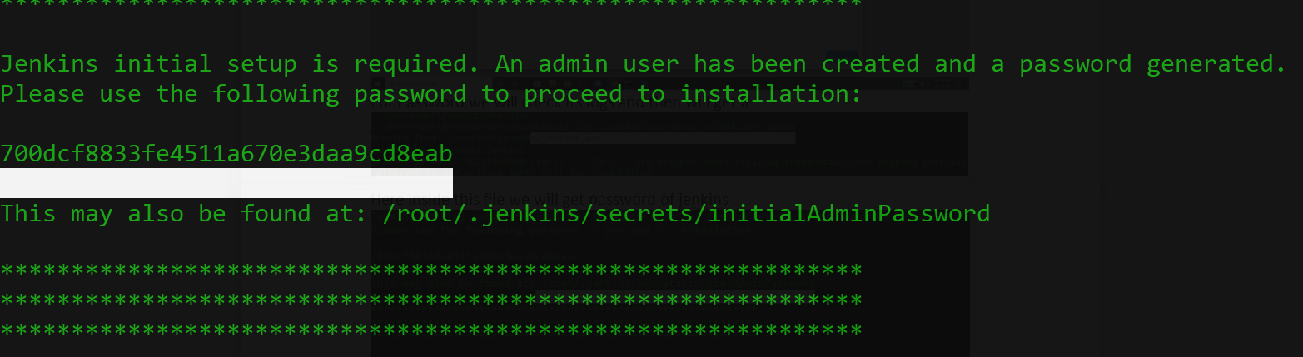

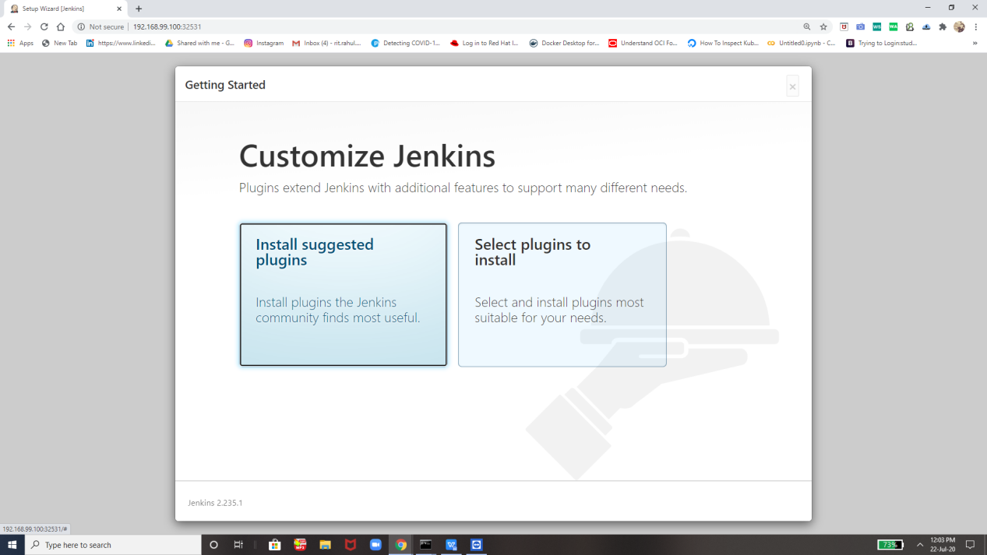

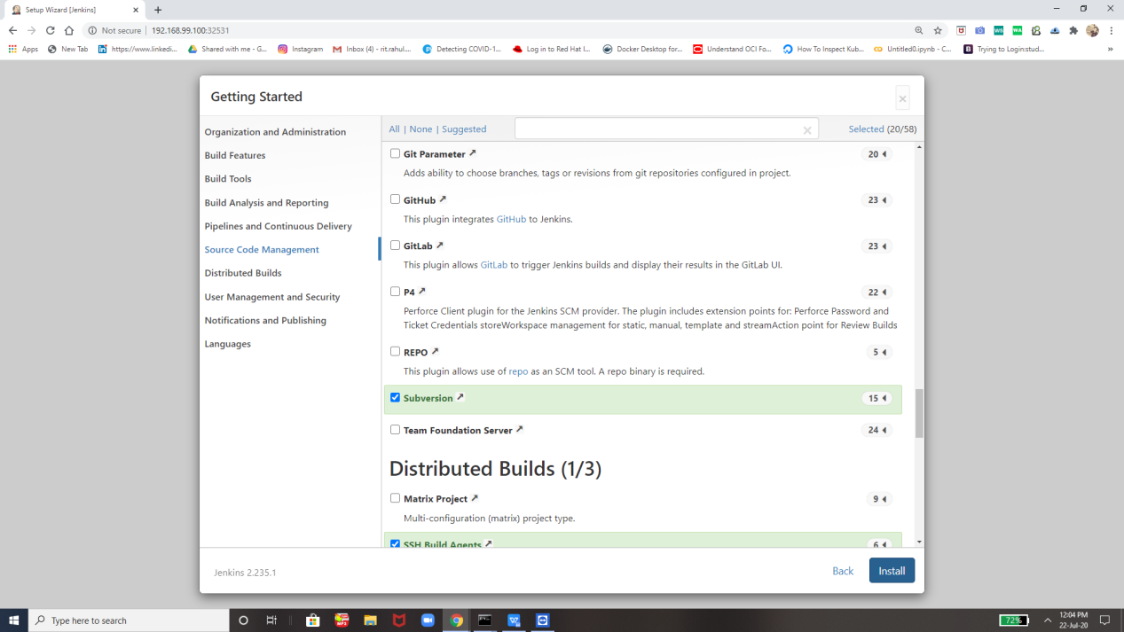

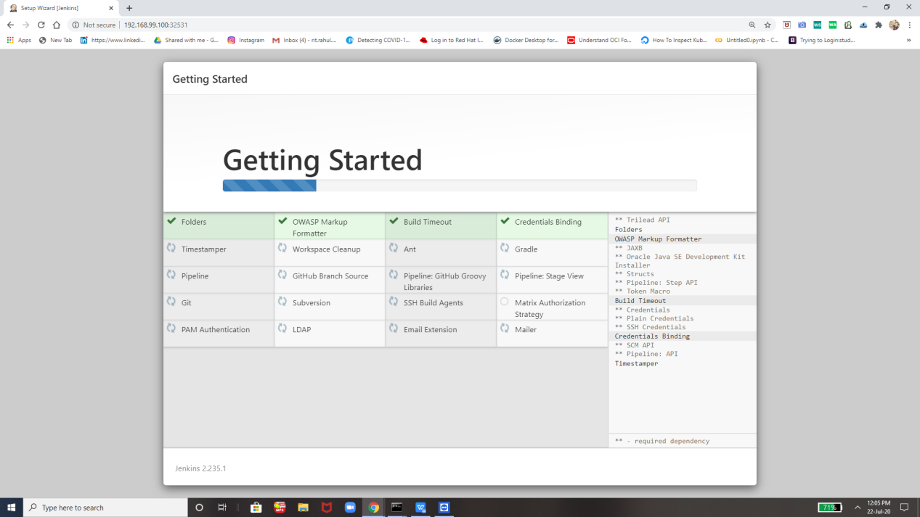

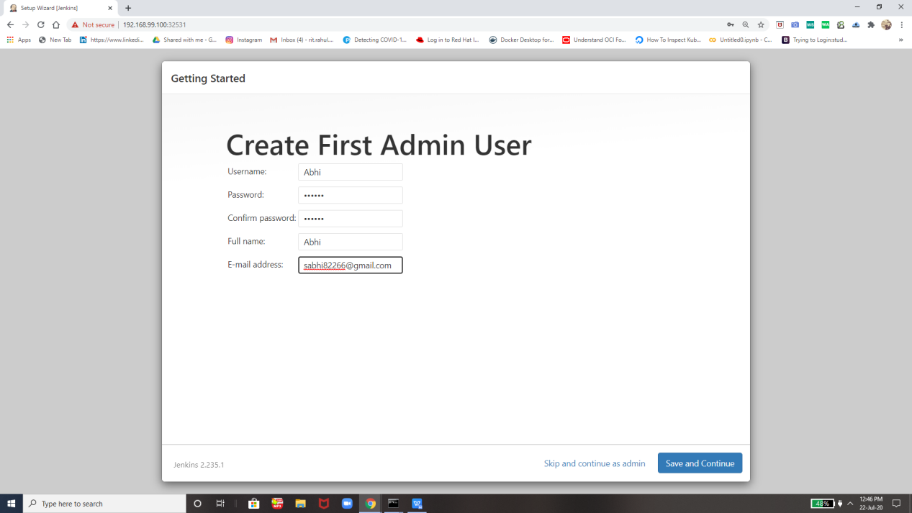

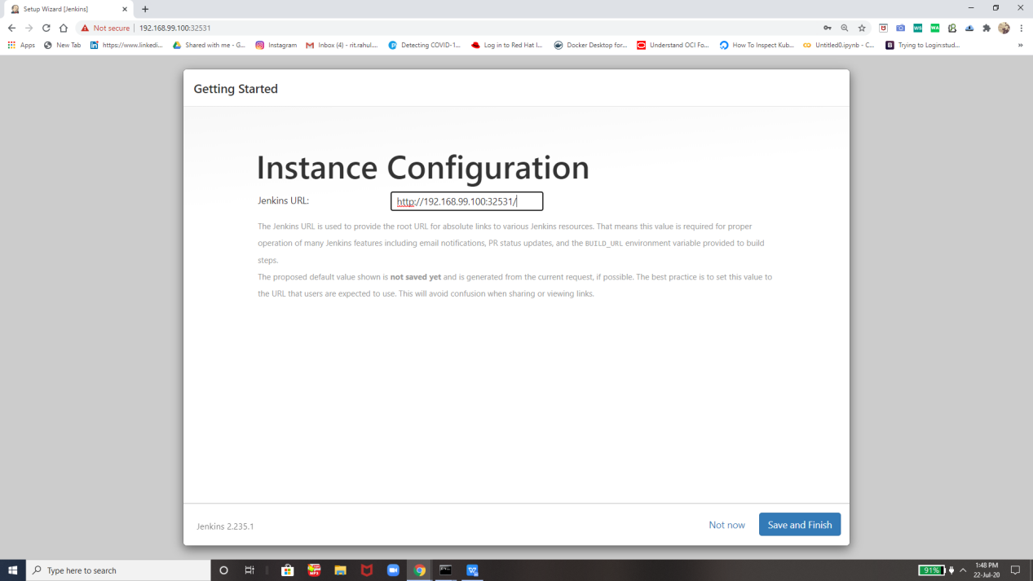

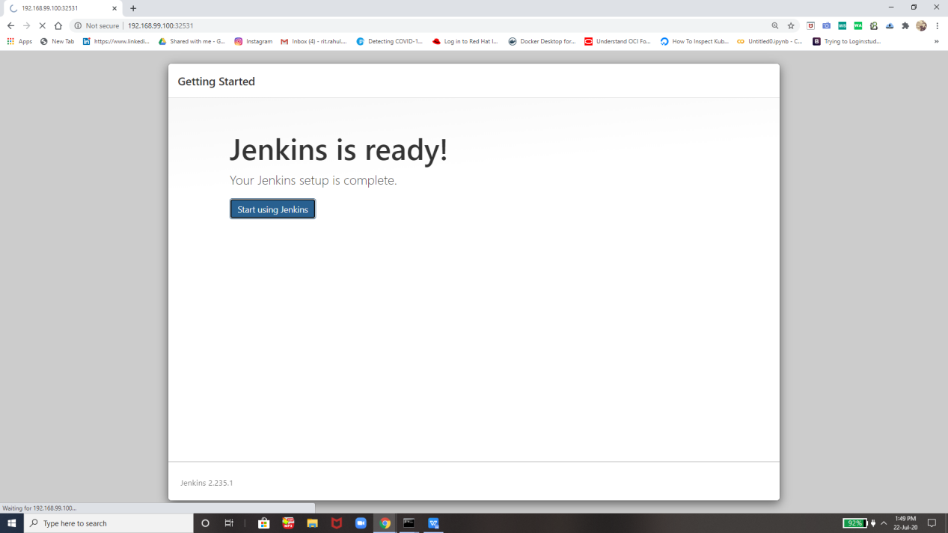

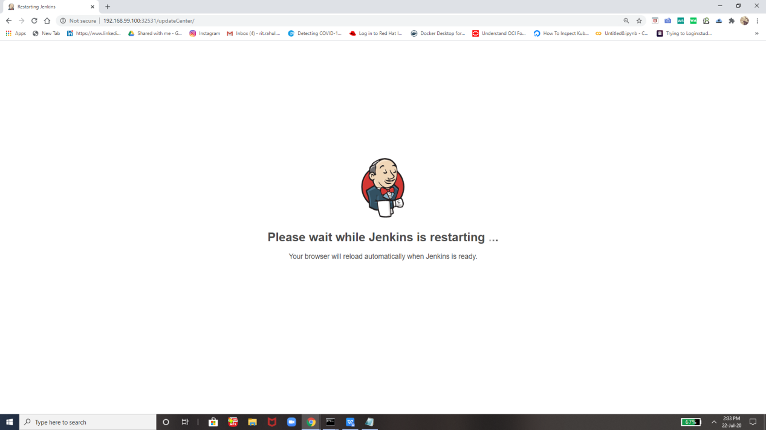

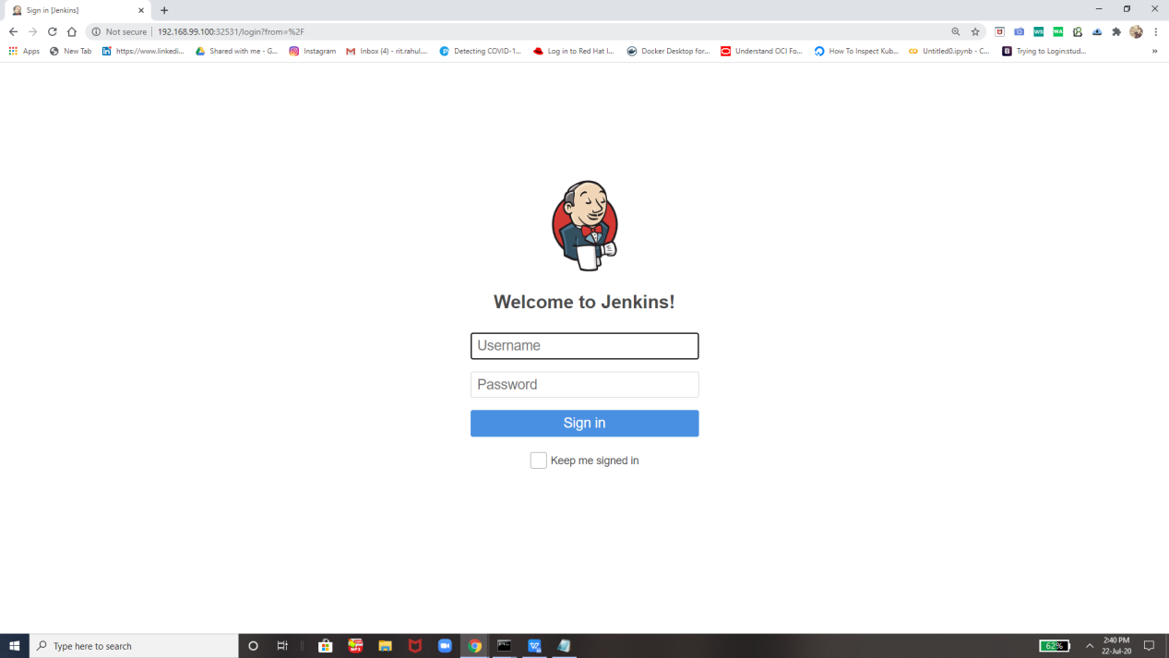

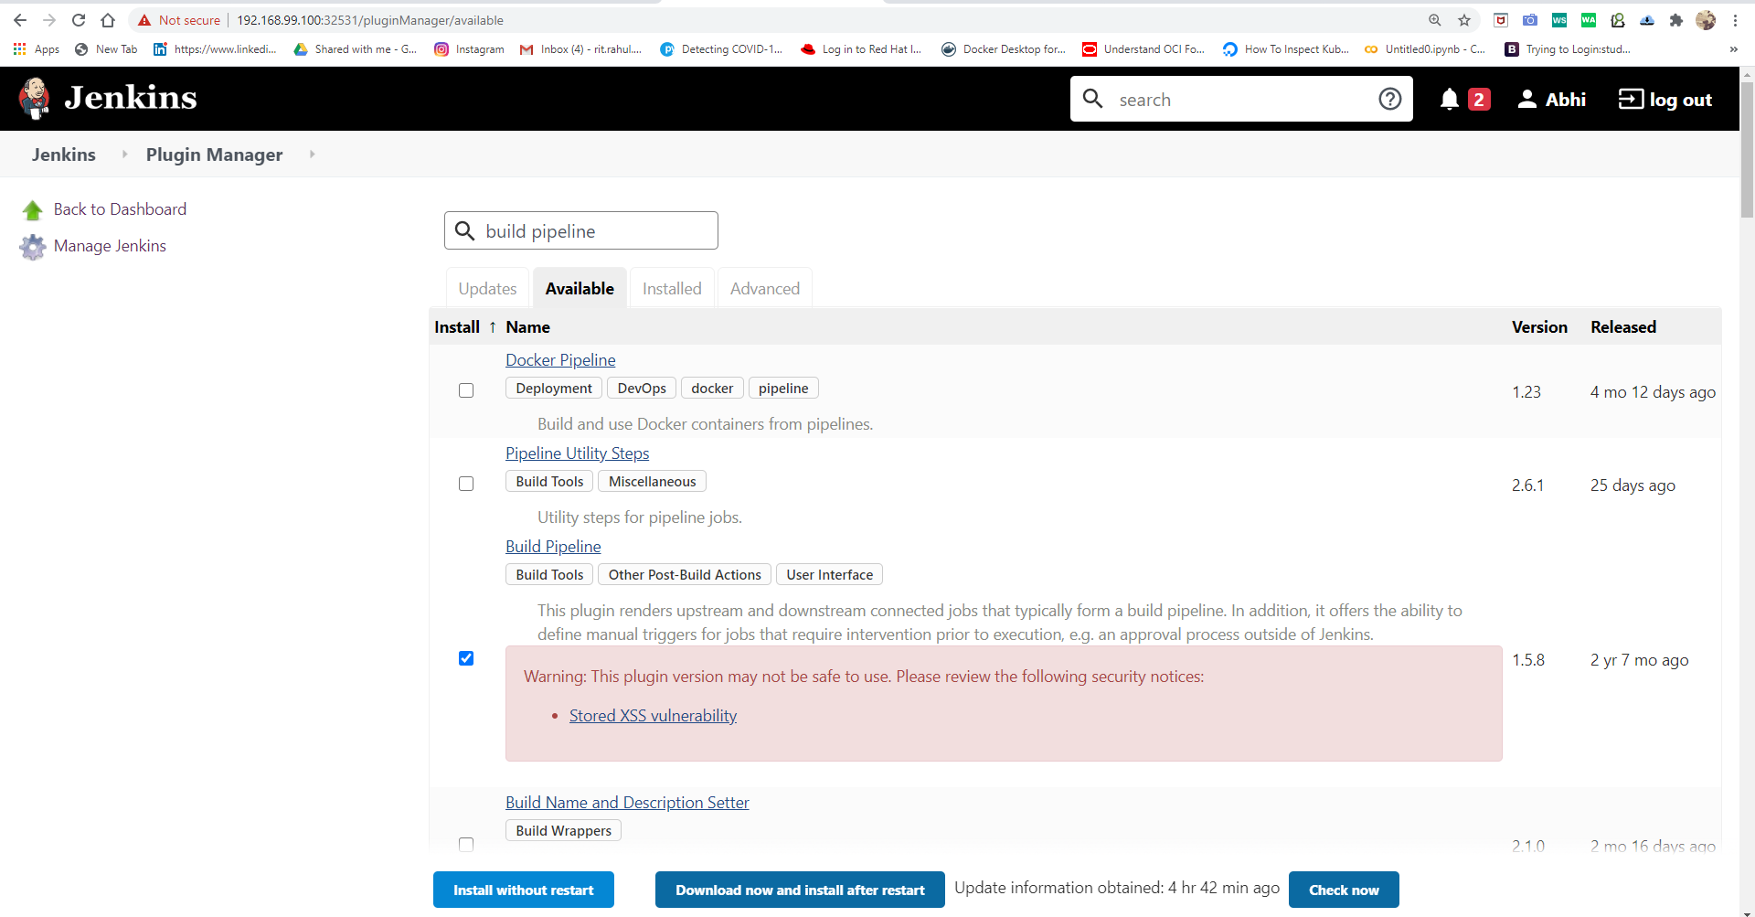

Here we go by creating dsl job so that all other jobs will automatically created by using the code

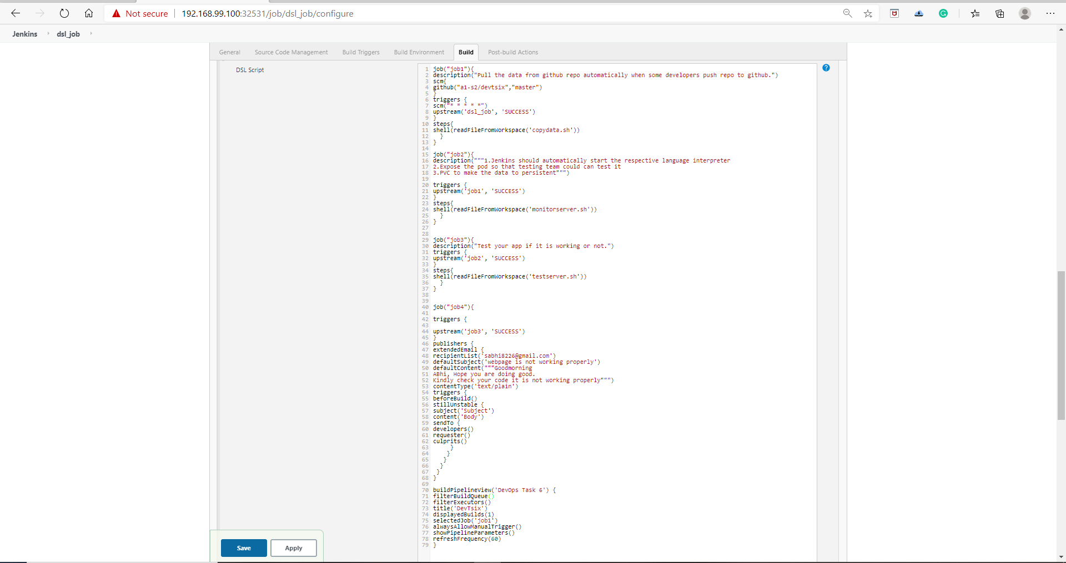

Job 1 :-

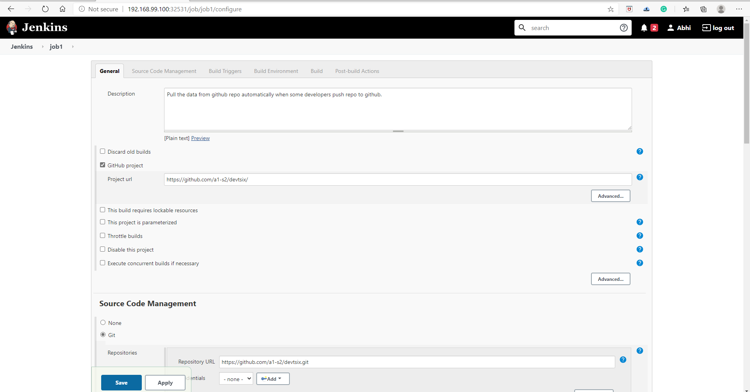

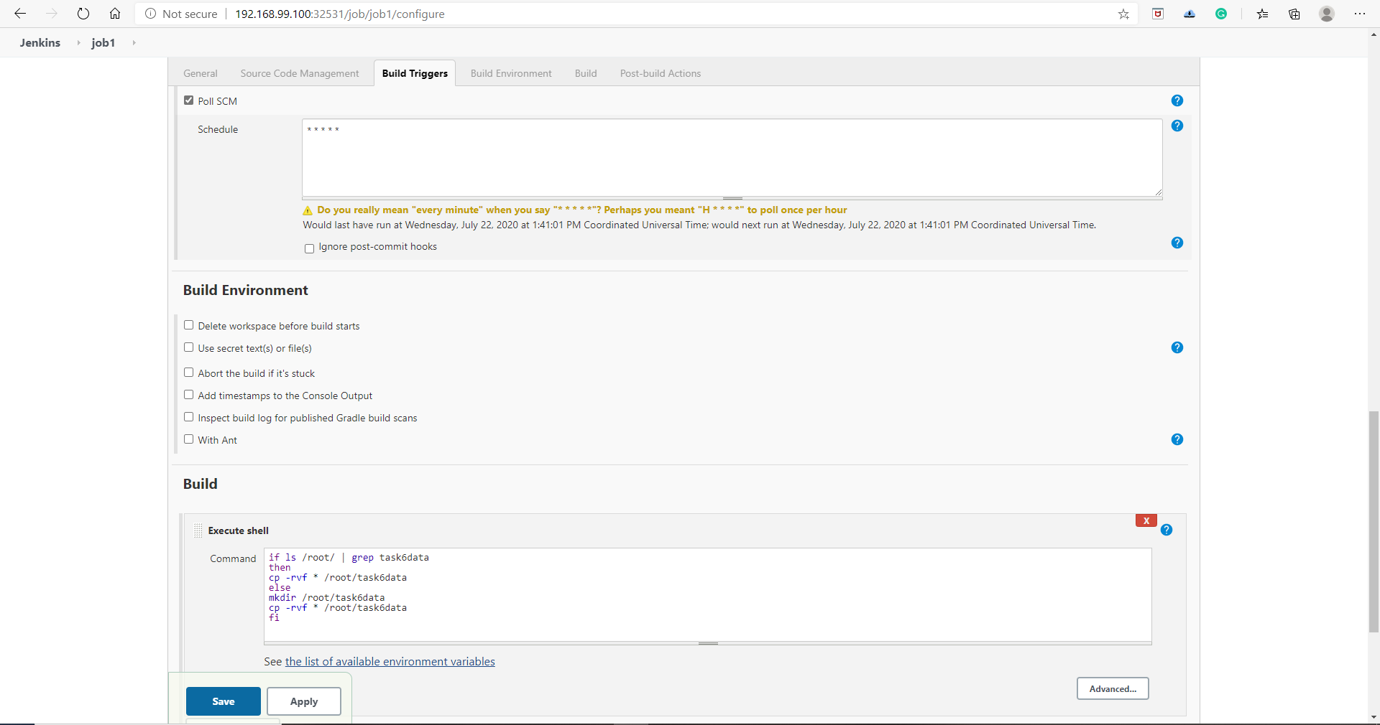

Job 2 :-

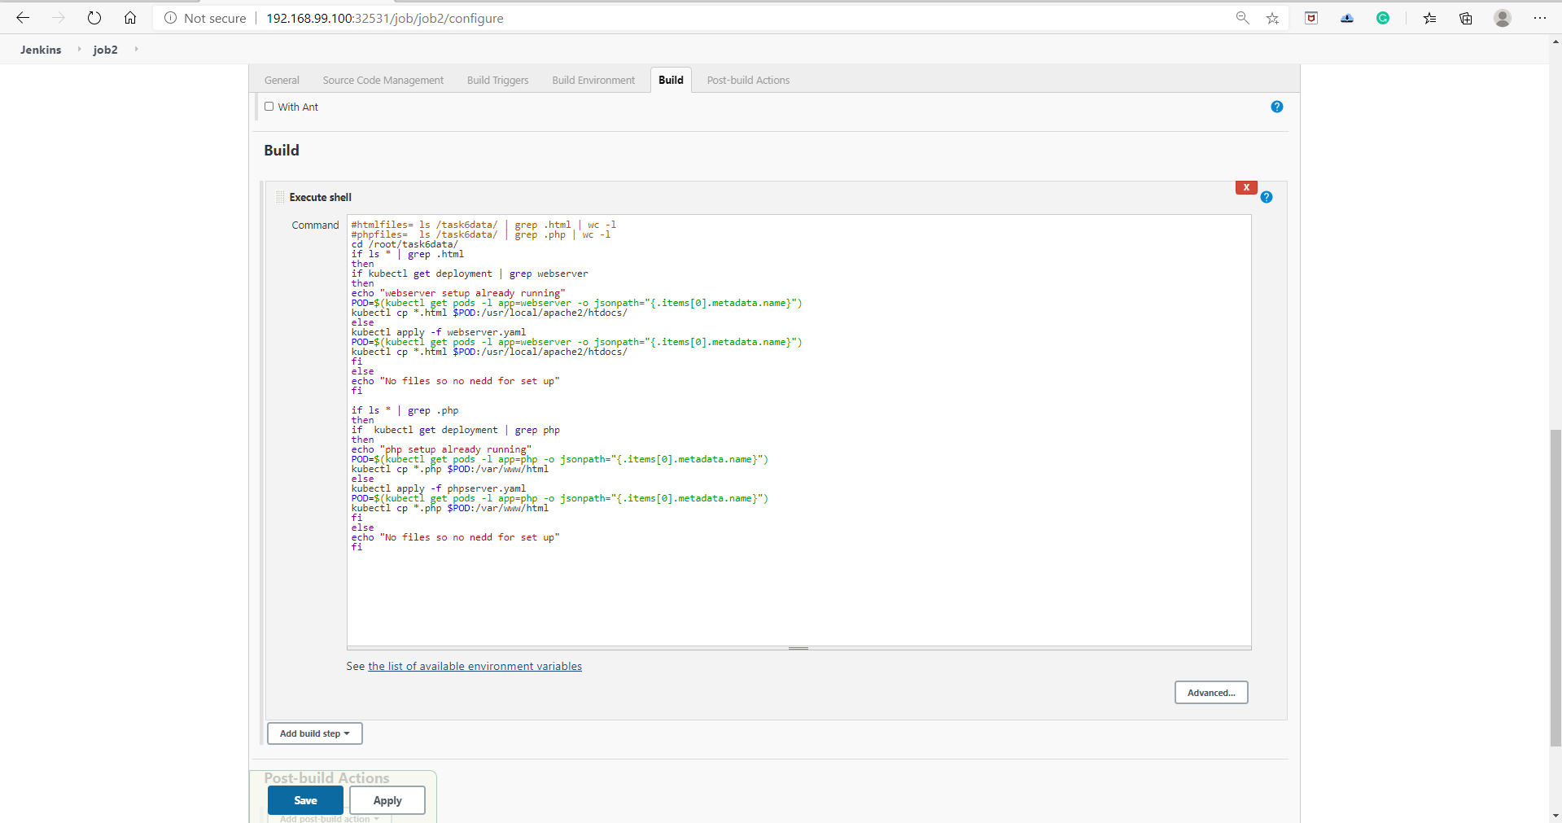

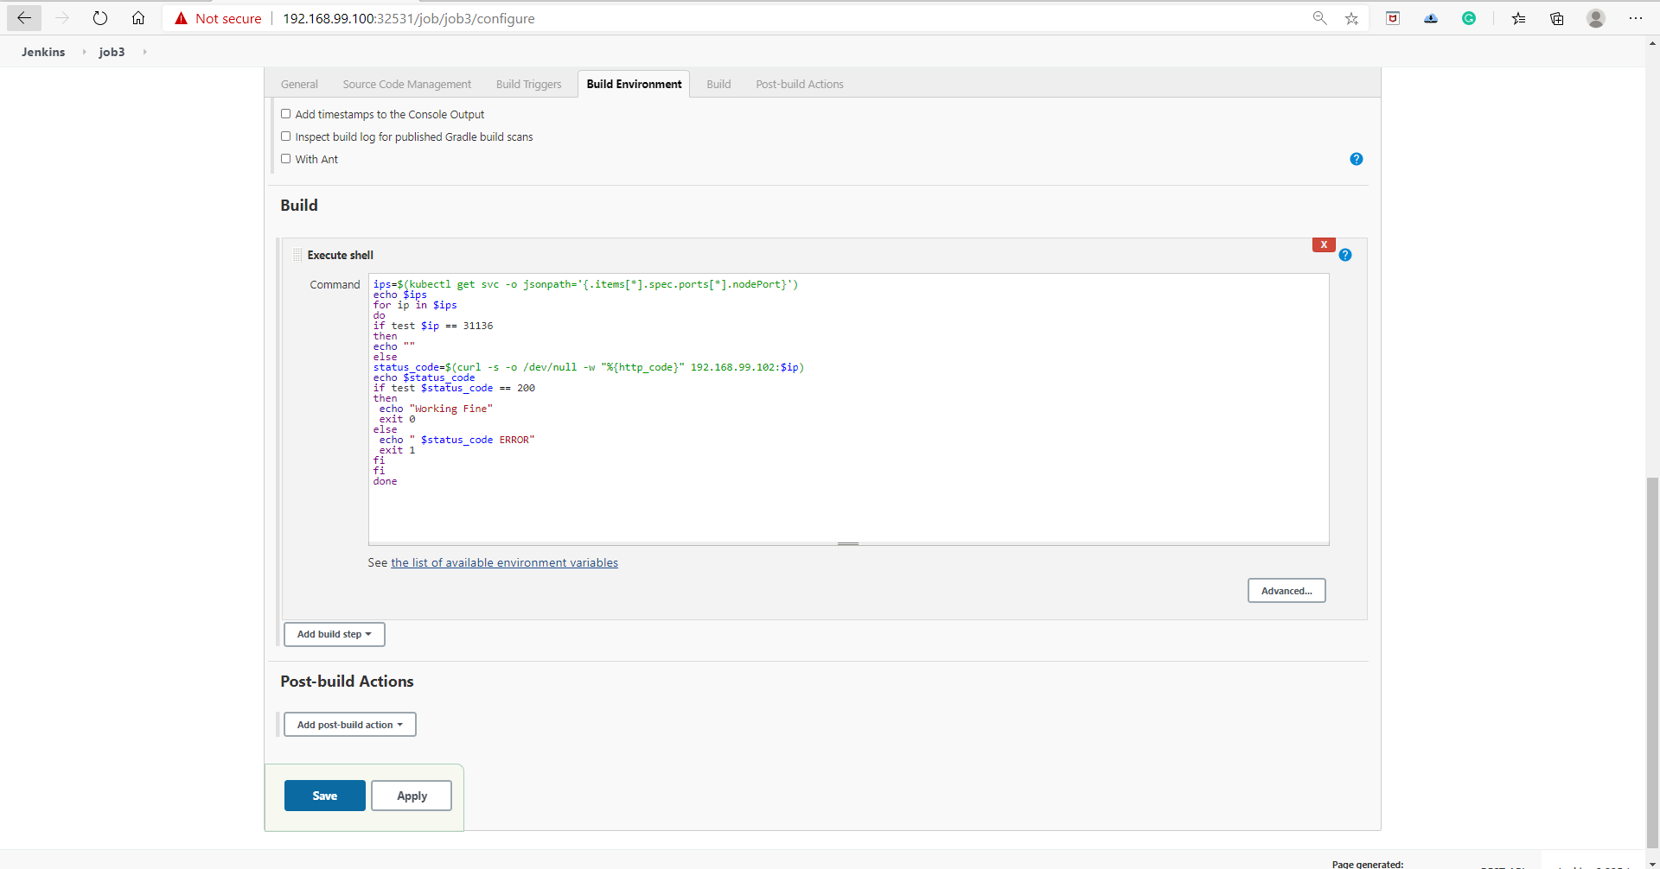

Job 3 :-



Job 4 :-

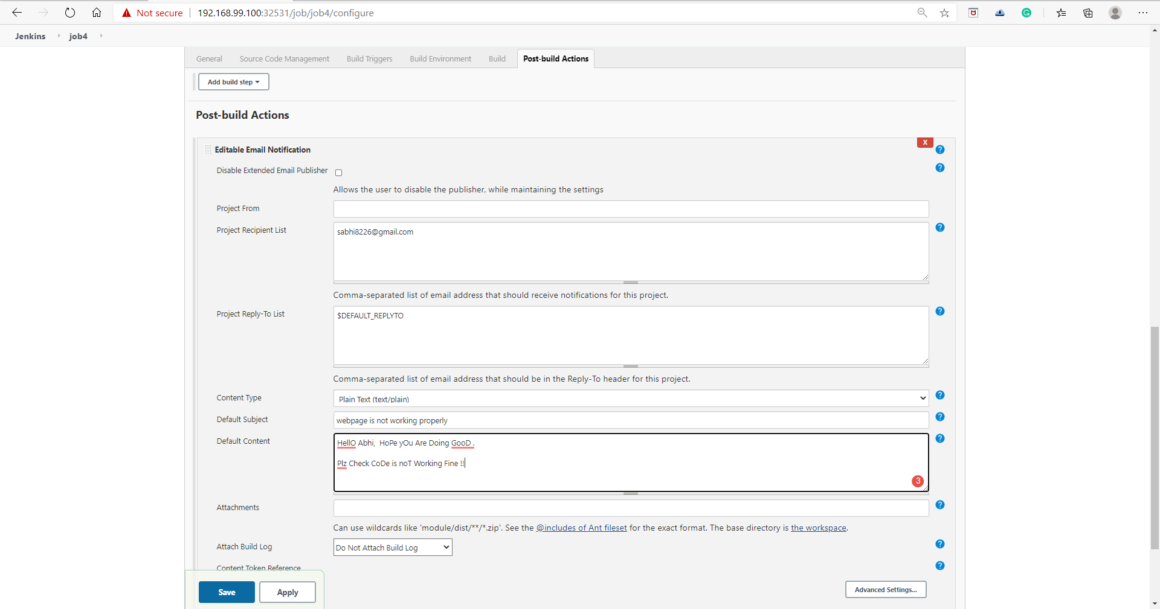

It will not send mail because every job is running successfully without any error

yOu can see everything is working fine.

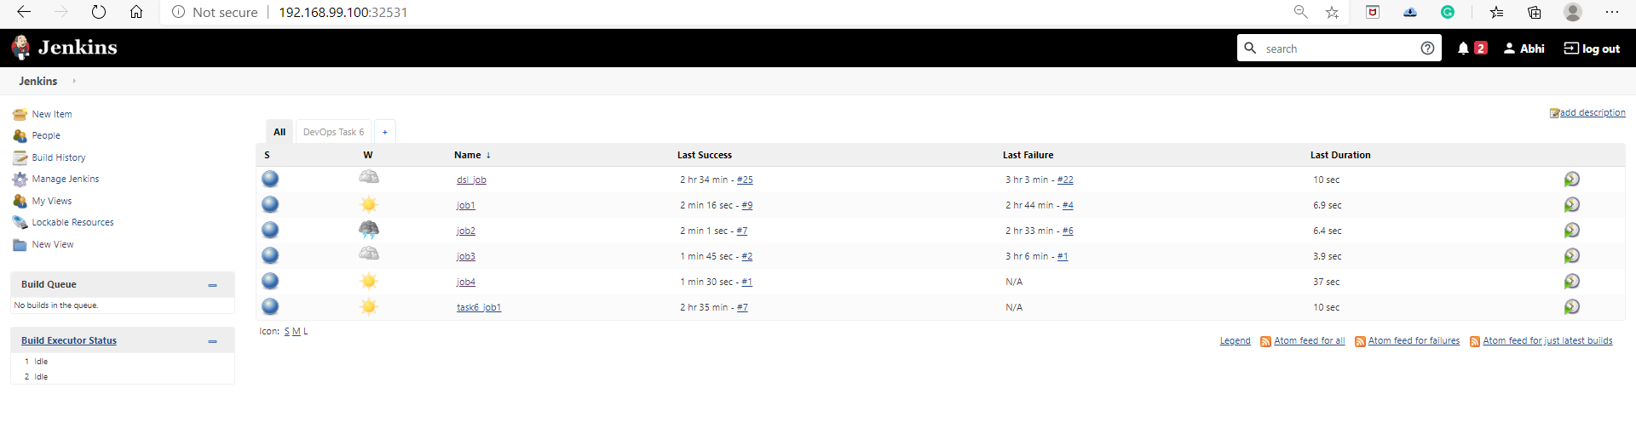

Builf Pipeline .

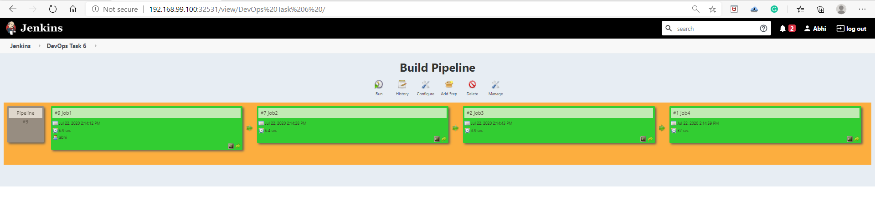



**Thanks you Vimal SIr For Teaching us so much intresting tools and technologies so that today we can create projects By Out Own .**

**Thank you EverOne For Reading !!**